  Albeerta Hudson 01    Napoleon Gilmore 04  Guadalupe Carrion 09  Nick Tzimorotas 17  Thomas Child 17  Nancy Good 19  Kathleen McEvoy 20  James Jimenez 22  INDEPENDENT LIVING  Edger Seidel 23  Joann Conyers 25  Elizabeth Andrews 27  Elizabeth Andrews 27  INDEPENDENT LIVING |  |  |  |  | 10:00 a.m. Spoon Crafts  part 2 (AR)  2:00 p.m. Bingo  (CH) | 10:00 a.m. Order of Malta  (WC)  10:00 a.m. Choir (AR2)  2:00 p.m. Movie (CH)
9:30 a.m. Donuts &Coffee  (CH)  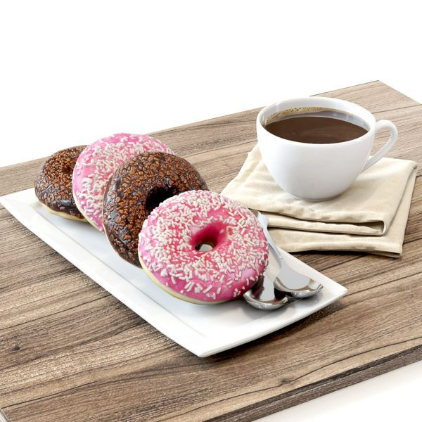  2:00 p.m. Astros Game  (CH) |   10:00 a.m. Coffee & Chat  (CH)  4:00 p.m. Astros Game  (CH) | 10:00 a.m. Breathing & Meditation (CH)  2:00 p.m. September Trivia  (CH) | 10:00 a.m. Draw Me A Clue  (CH)  2:00 p.m. Resident Council/Calendar Review  5:00- 7:00 p.m. Happy Hour (CH) | 9:00 a.m. Walmart  10:00 a.m. Breathing & Meditation (CH)  6:30p.m. Prayer Group  (AR) | 10:00 a.m. Coffee & Chat  (CH)  2:00 p.m. Bingo  (CH)  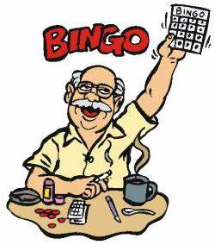 | 10:00 a.m. Choir (AR2)  2:00 p.m. Card Games  of your Choice  (CH)
  9:30 a.m. Donuts &Coffee  (CH)    1:00 p.m. Texans vs Ravens  (CH) | 10:00 a.m. Spoon Crafts  part 3 (AR)  2:00 p.m. Card Games  (CH | 10:00 a.m. Breathing & Meditation (CH)  2:00 p.m. Food Committee  Meeting (CH) | 10:30 a.m. Lunch at Silver Palace  5:00- 7:00 p.m. Happy Hour (CH)   | 9:00 a.m. Kroger  2:00 p.m. Fresh Baked Cookies & Karaoke Social  (CH)  6:30p.m. Prayer Group  (AR) | 10:00 a.m. Jewelry Making (AR)  2:00 p.m. Bingo  (CH) | 10:00 a.m. Choir (AR2)  2:00 p.m. Card Games  of your Choice  (CH)
9:30 a.m. Donuts &Coffee  (CH)  1:00 p.m. Texans vs Colts  (CH) | 10:00 a.m. Coffee & Chat  (CH)  2:00 p.m.  Birthday Celebration  With Curtis Nickelson  (CH) | 10:00 a.m. Breathing & Meditation (CH)  2:00 p.m. Canasta Card Game  (CH) | 9:00 a.m. Target  2:00 p.m. Book Talk  Circle (AR2)  2:00 p.m. Astros Game  (CH)  5:00- 7:00 p.m. Happy Hour (CH) | 9:00 a.m. Casino Trip  10:00 a.m. Breathing & Meditation (CH)  6:30p.m. Prayer Group  (AR) | 10:00 a.m. Button & Bows Sewing Group (AR)  2:00 p.m. Bingo  (CH) |   10:00 a.m. Choir (AR2)  2:00 p.m. Movie & Popcorn (CH)  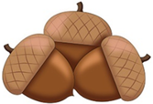
9:30 a.m. Donuts &Coffee  (CH)  1:00 p.m. Texans vs Jaguars  (CH) | 10:00 a.m. Drum Circle  (AR)  2:00 p.m. Scrabble Game  (CH) | 10:00 a.m. Breathing & Meditation (CH)  6:30 Sing A Long with  Jr. League  (CH) | 10:00 a.m. Learning  Lecture and  Exercise with Amir  (AR2)  5:00- 7:00 p.m. Happy Hour (CH) | 10:00 a.m. Breathing & Meditation (CH)  6:30p.m. Prayer Group  (AR) | 9:00 a.m. HEB  2:00 p.m. Bingo  (CH) | 10:00 a.m. Choir (AR2)  2:00 p.m. Card Games  of your Choice  (CH)
Warren Chapel- MASS Daily at 12 noon -ROSAR Daily 4:00 p.m. -ADORATION Tuesday and Thursday 3:00 p.m. Sunday Mass 10am ACTIVITIES ARE SUBJECT TO CHANGE WITHOUT NOTICE
Sunday | Monday | Tuesday | Wednesday | Thursday | Friday | Saturday
 |  |  |  |  | 1 | 2
3 | 4 | 5 | 6 | 7 | 8 | 9
10 | 11 | 12 | 13 | 14 | 15 | 16
17 | 18 | 19 | 20 | 21 | 22 | 23
24 | 25 | 26 | 27 | 28 | 29 | 30

